**MILESTONE 1 Documentation - UG041 - XMLHtttp**

**Research -**

1. Log in page

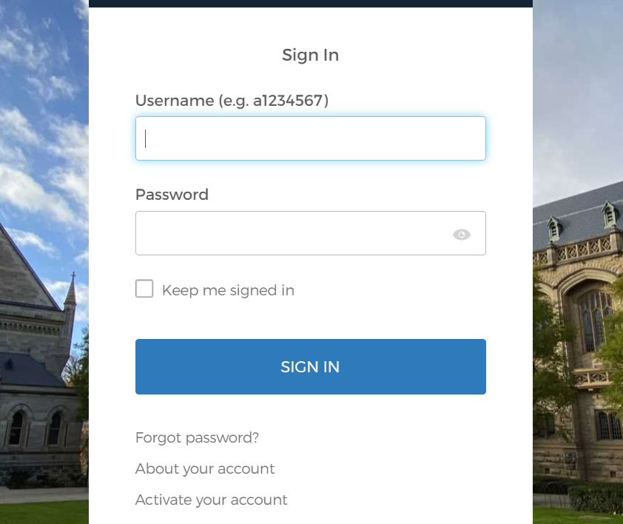

Keep me signed in is beneficial as it is convenient for the user by avoiding the need to log in every time.

The password can be viewed on clicking the show button.

The input field has well-defined names allowing the user to know where to enter his credentials.

Clicking on the input field displays a highlights the area using blue border.

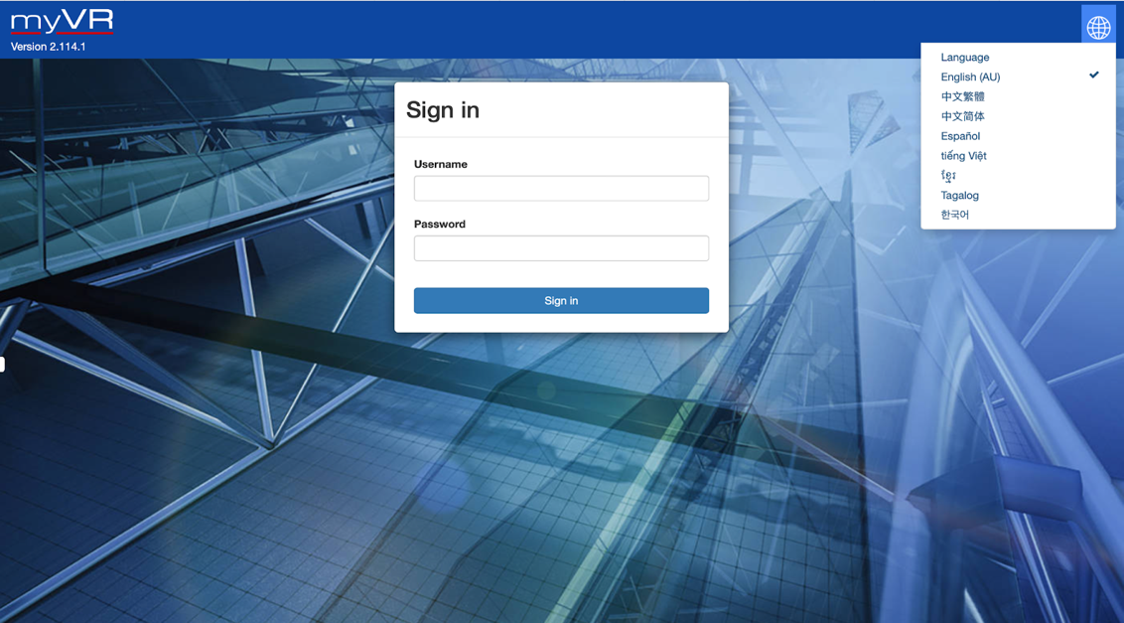

Flexibility to change the language.

A logo of the page in the corner gives an idea if the user is at the correct website.

Lacking an option to sign up for new users.

1. Sign up page

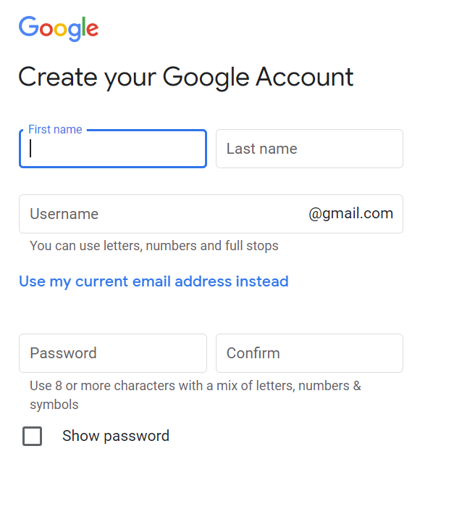

Asks user to input all the required details needed to register as a new member.

Confirms the password before registering the user to avoid mismatch.

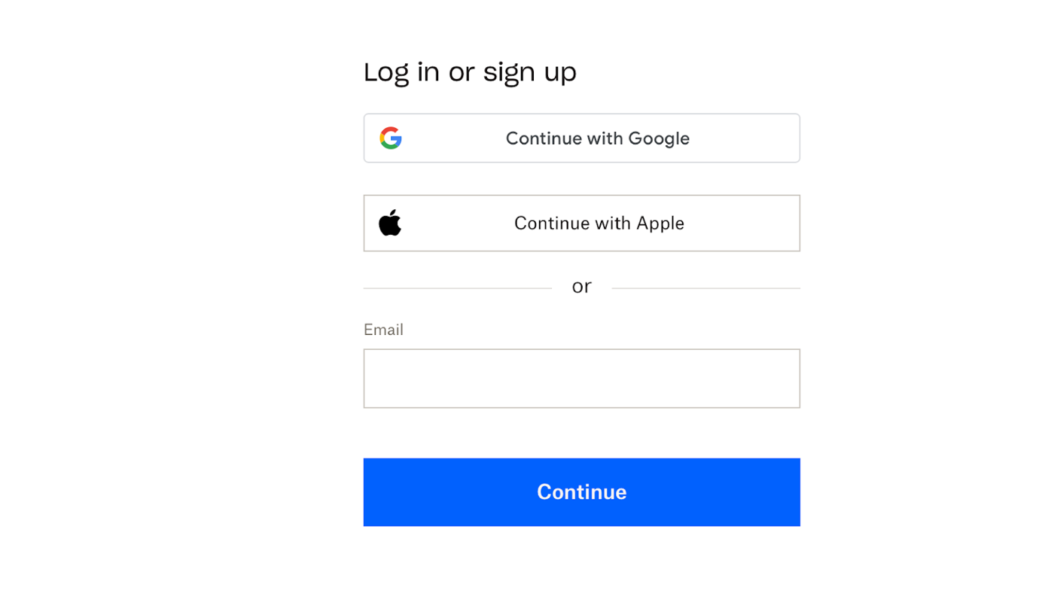

Allows flexibility to sign up using google account but the user cannot sign in using social media account such as Facebook.

1. Account setting

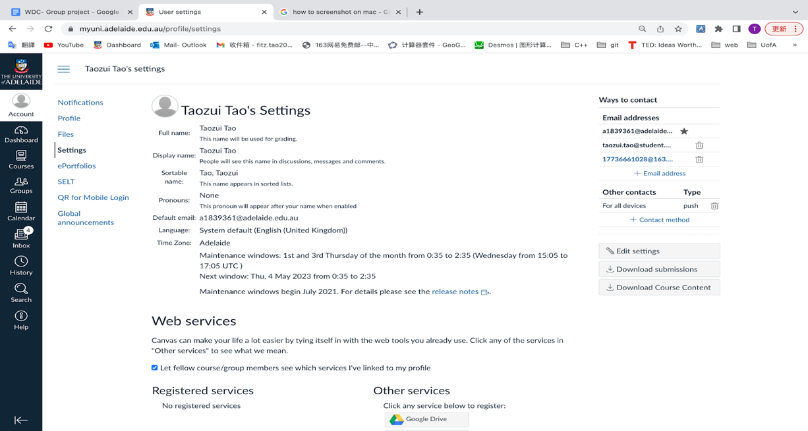

Clearly display all user information

The language can be changed according to the system default language,

1. Main page

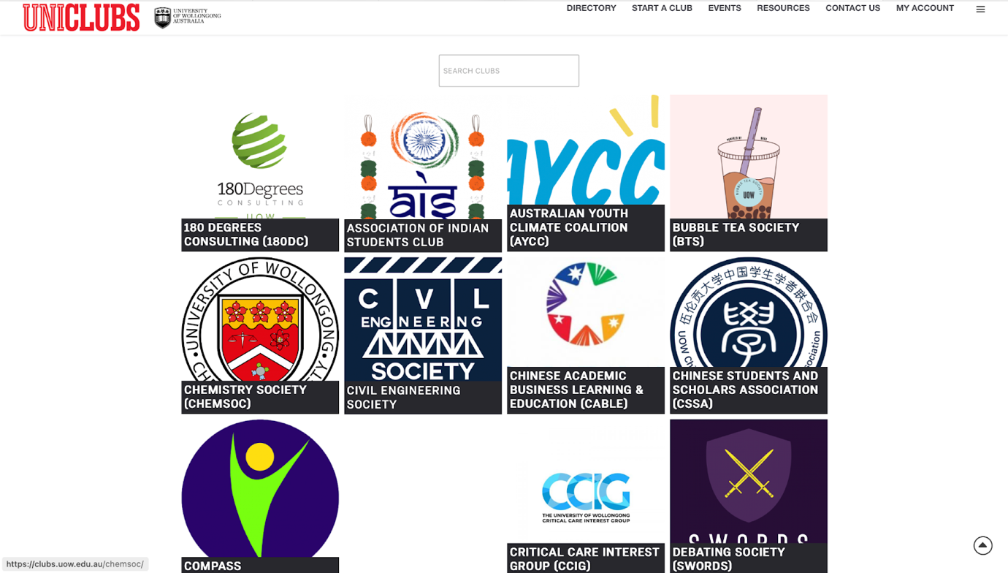

The page allows user to see the various available clubs and search for clubs.

All display clubs are not categorised.

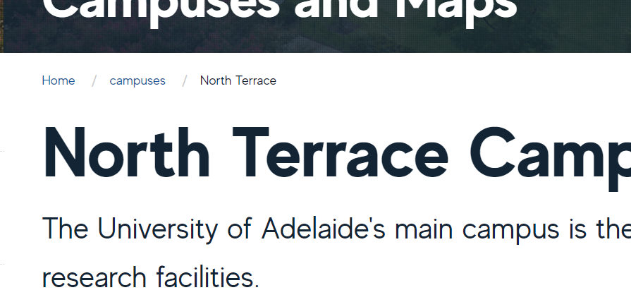

As the user goes deeper into the page, a small navigation is displayed under the header to keep track of its current location.

* The website will promote the log in and the log in and the sign up buttons in the top right corner

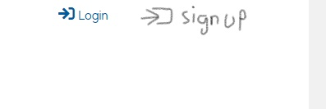

* After the user login, the login button will be replaced with the “logout button - username



This will serve the purpose of logging in and out for all users, this way of implementing the logging in will let the user know if he is already logged in or not to the account, also it is easy to implement and the users should not face difficulty understanding the purpose of them.

- Sign-in will promote to the user a simple page that contains an input box for the user email and password. The sign-up page will follow the same style but with account setup information, which are email, user name, password and password confirmation.

- The user profile will make the user able to manage their information like the first, last name and password but they cannot change their username or the email.

2. The search bar will make the users able the search for clubs and save time, the search bar doesn't have great usage for the website as it is just started, but with the passage of time and the admins add lots of clubs the search bar will gain a huge advantage, especially for the new users who want to have a quick overlook on the website.



3.     Create a main page for User, Manager and Admin, as the users login their account authorisation will fetch the information they need, for example, the user account will only be promoted with the user information.

4.       Description about the website that just describes the main goal/purpose of the page.

5.    clubs view for users: the clubs will be promoted to the users as rows of squares and each square will have:

1. image that contains the club symbol or whatever the admin desires.
2. a little description paragraph about the club
3. a drop-down list to view all sections under that club, for example, if it was a sports club the drop-down list might contain: soccer, football, baseball, tennis and so on.

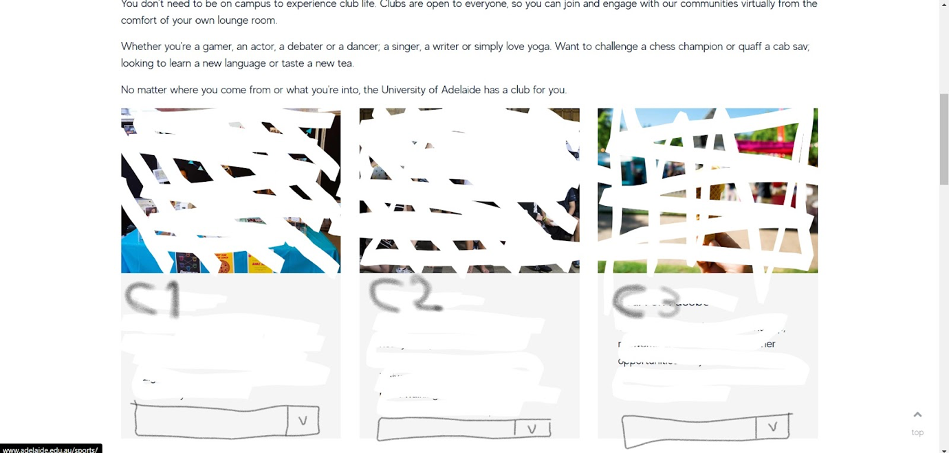

6. Events calendar (list for events and date), here is where is all club events will be promoted as a list for the club members.

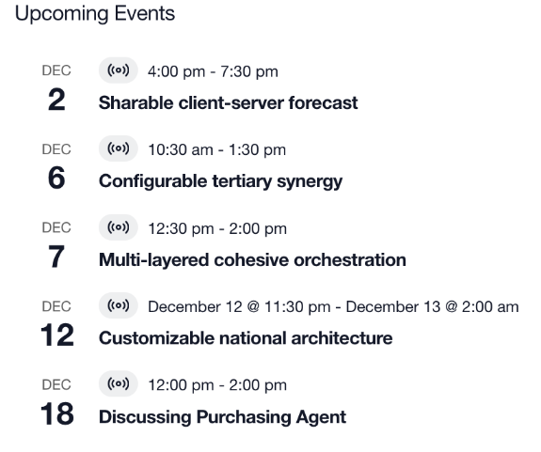

7.     (might be not necessary) Interaction with messages/posts for example being able to click on like or dislike and being able to reply/comment.

8.  (might be not necessary) In the main page or inside the club make a place/link to report problems

9.    (might be not necessary) Club manager can create different topic sections like if it is a gaming club there should be a place for announcements, general chat, sports game chat, rap games and so on.

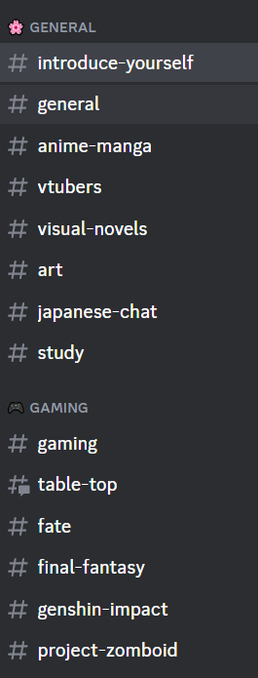

B. Features-

1. Login and Register page

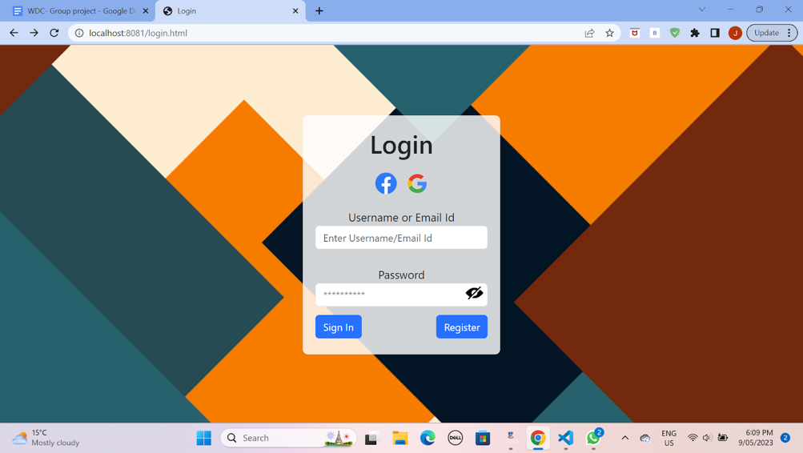

This is the login page of our site. Whenever the user is on the main page and tries to login into their account this page will appear. The icons and the buttons on this page will be highlighted when the user hovers over them.

When entering the username or password the borders around the box will be highlighted for better user experience.

For privacy and protection the password will not be seen unless the “eye” button is clicked in which case user can see what they have typed into the box and hide it by clicking on the button again.

On clicking the sign In button the user will be directed to the main page with his logged in as the user.

If the user is new to this website he can click on the register button to create a  new account.

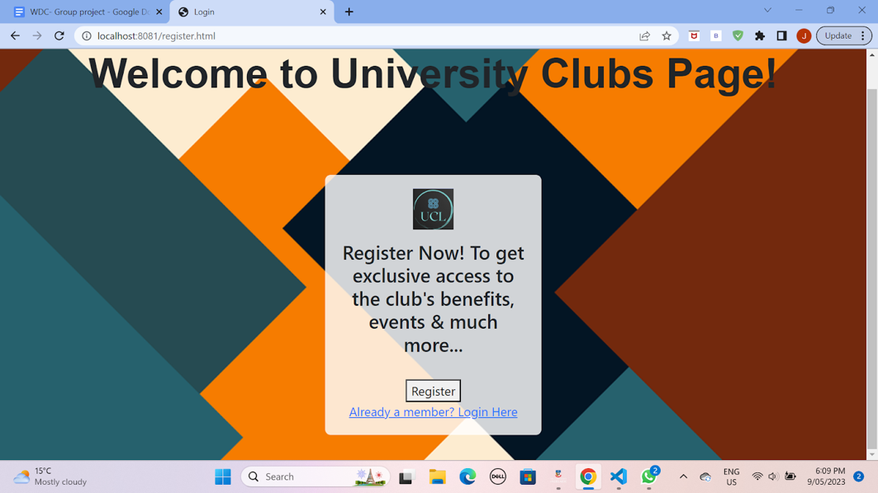

This is the Register page of our site. This page will appear when there is a new user who is creating their account for the first time.

At the bottom there is also an option for going back to the login page in case the user remembers that he already has an account here.

When the user clicks on the register button a form pops up which asks the user to provide their name, username, email and password.

There's also Confirm password button which ensures that the user has typed the correct password in and for privacy and protection the password will not be seen unless the “eye” button is clicked in which case user can see what they have typed into the box and hide it by clicking on the button again.

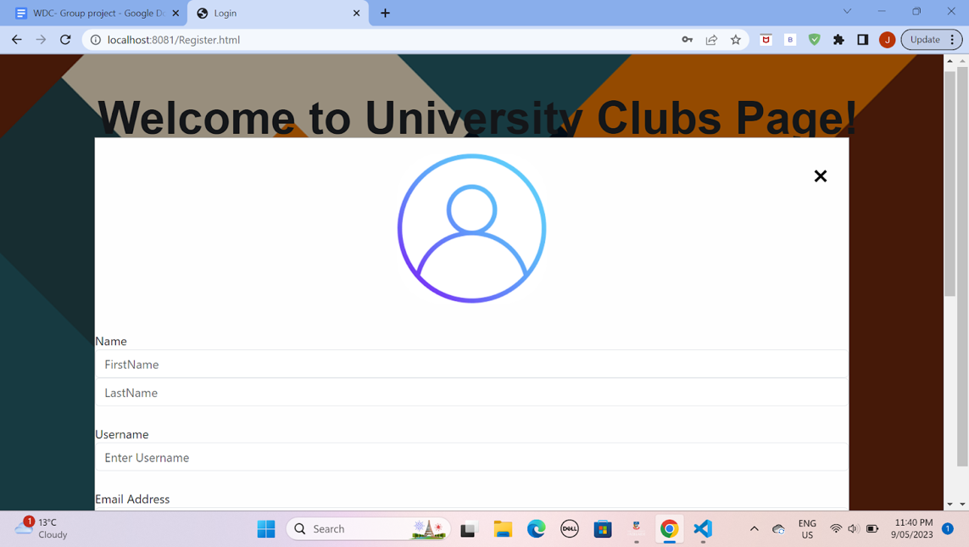

1. Main Page

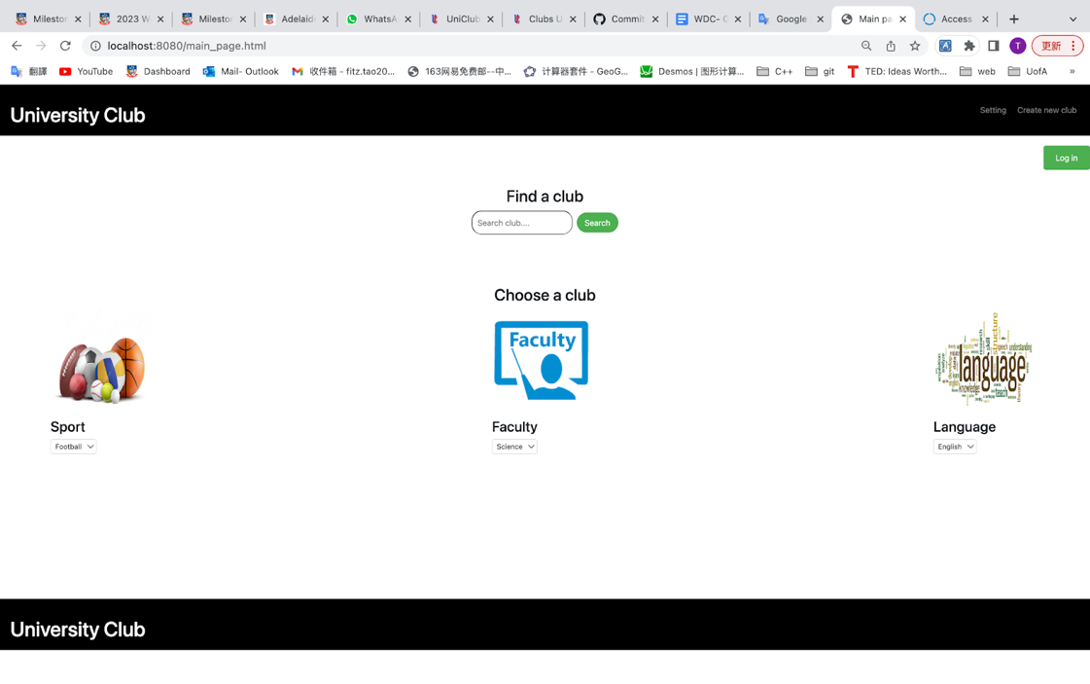

This is the main page of this site. Users can see this interface first when they are not logged in. This page contains the Settings button, the Create New Club button, and a search box which is used to search for clubs. There is also a drop-down list of club selections already categorised. Users can find existing clubs from the categories. Also, there is a green login button in the upper right corner. When the user presses this button, the program will jump to the login page.

In a previous research, UOW's club website was below the search box and they listed all clubs without categorization. So we decided to use category dropdowns instead.

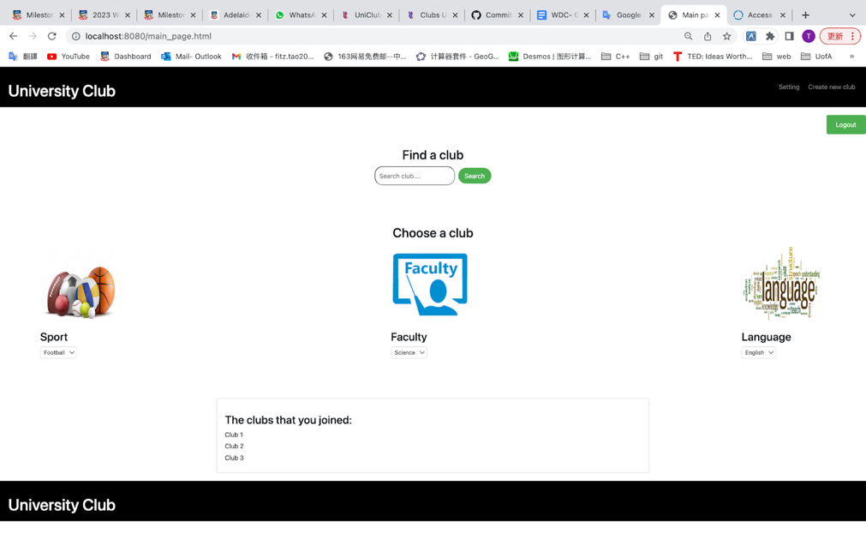

When the user finishes logging in, the program will return to the main page, and the green login button in the upper right corner will change to a green logout button. Also, a list of clubs that the user has joined will appear below the drop-down selection bar.

1. Your Details page

The user details page allows the user to edit his personal details such as first name, last name and date of birth. This page can only be accessed when the user is logged in. Any changes made to these details updates the database. It also contains a contact section where the user can see the admin’s contact information if any issue arises with regards to the club.

Clicking on ‘home’ on the top would allow him to go to the university club page and clicking on ‘about’ will display details of the university clubs.

1. Admin’s page

This is the admin’s portal or the admin’s page. It allows the admin to control users and club managers. The page also has flexibility to remove user and club managers. Other admins can be added by entering their username and password.

In the event, the admin is already added, admin will be notified. In other case, if admin’s preferred username is already taken, the admin will be notified.

1. Club page (user view)

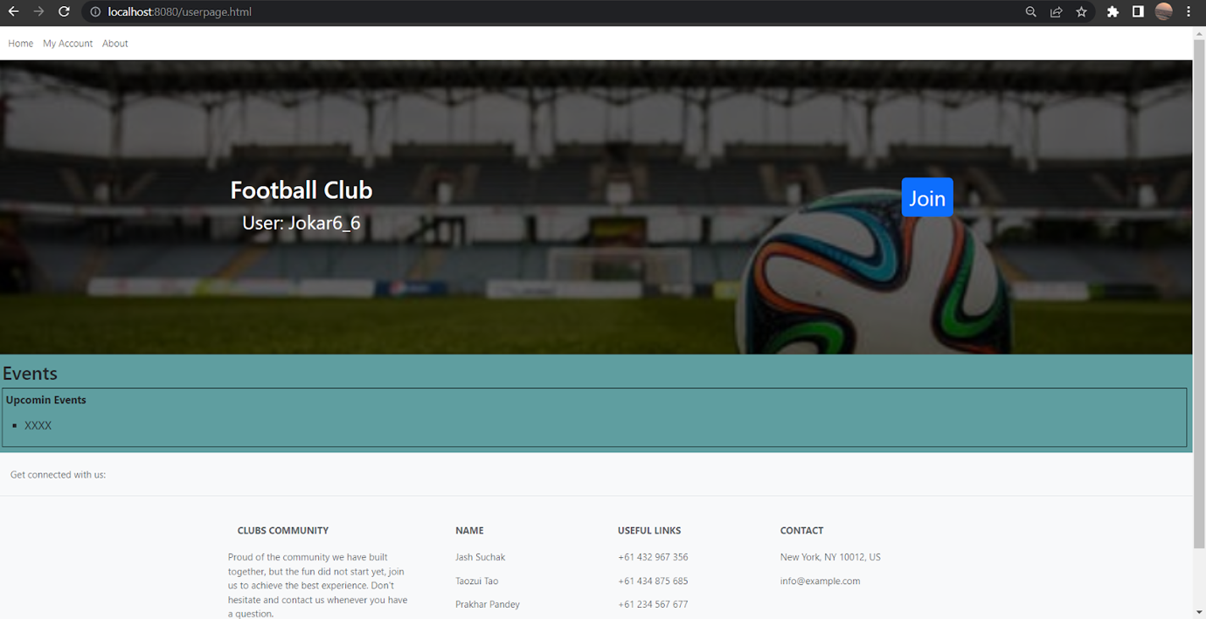

This page will appear when the user selects the club they wanted from the main page. At the top of the page, the user can click on the titles on the navigation bar to move to other pages, also there is About button which will pop up an information box about the club.

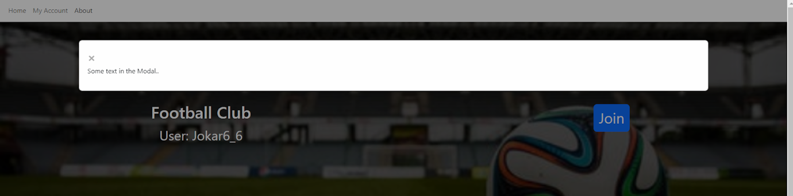

Underneath that, there is a join button, and when the user clicks on it the user will be a member of the club and the text will change to "Leave club". Under that, the users will be able to see the club events and they should be able to see the event title, date, and location. finally, the footer contains some details that might helpful for the user such as the contact details of the website admins.

1. Club page (admin view)

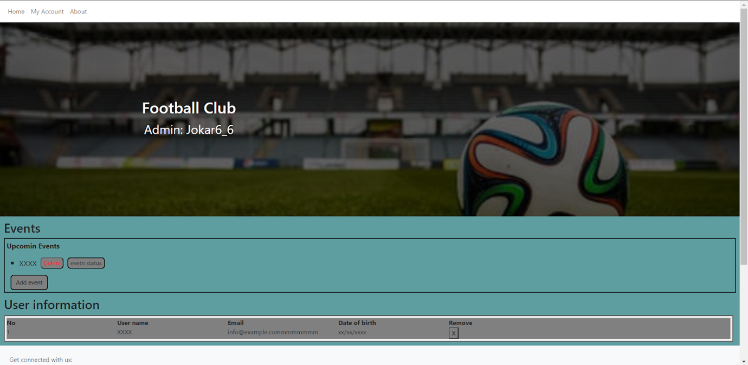

This page will appear when the admin selects the club they wanted from the main page. overall the admin page is similar to the user page but with additional information. The admin will be able to create and delete events, if the admin clicks on the add event button a window will pop up to enter the following information: title, location, date and event status(public or private), then the admin confirm by clicking ok to add the new event, the admin also can delete the event they have added by clicking on the delete button. furthermore, the admin can delete the member from the clubs, in the user information box the admin can click on the (x) button to delete the user membership.

C. Design

1. Login & Register page

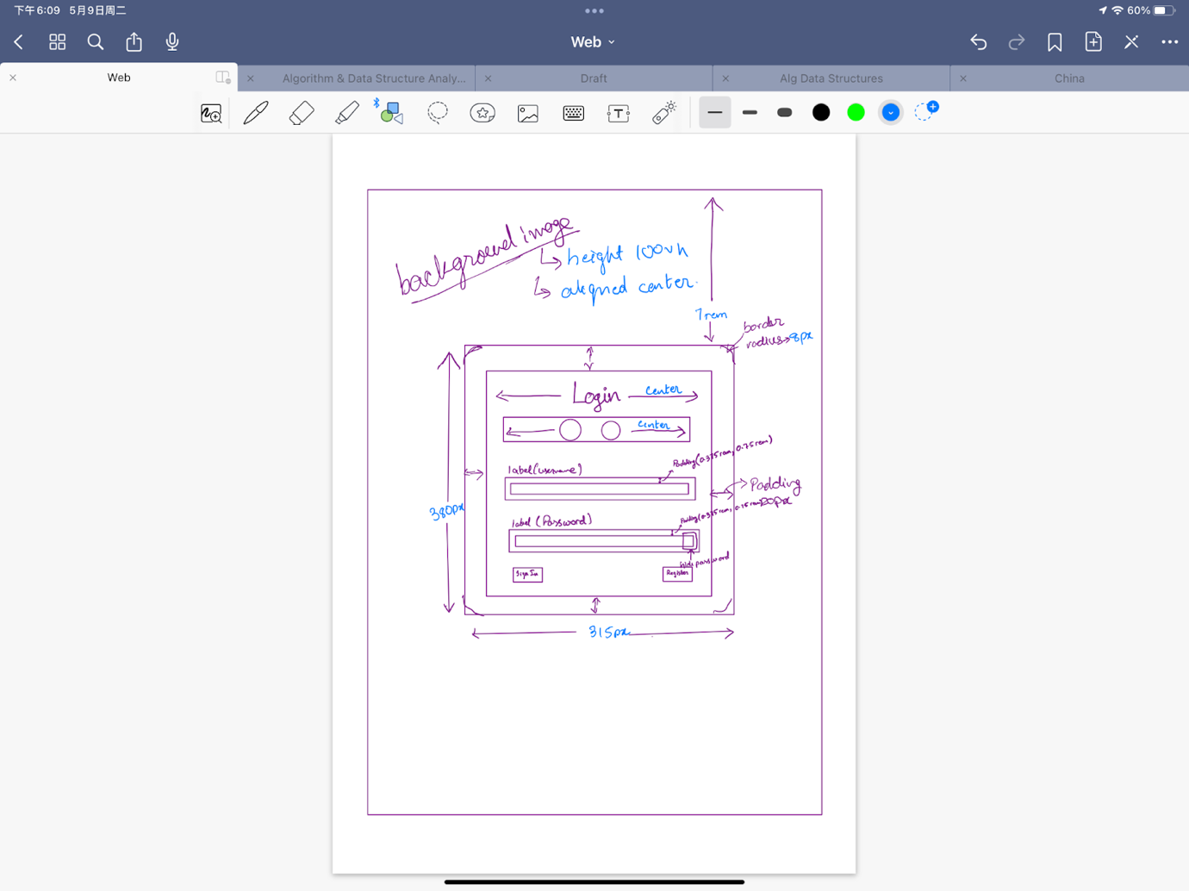      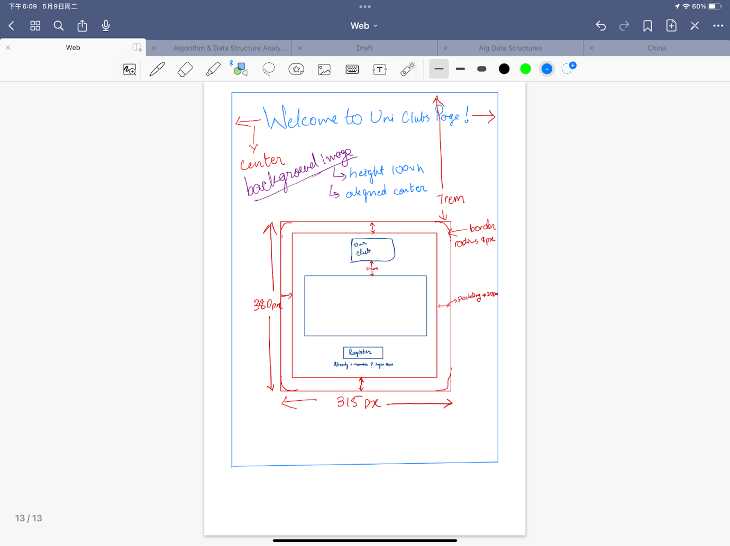

The design of the login and the register pages are simple. Login page has the main login box in the centre of the page with username and password as the input fields and a button to either side. The input fields are clearly labelled and have a clear placeholder text to guide the user. Login button logins into the main page and another button allows the user to register and make a new account.

The register page has a heading and box in the middle of the page. This box has the logo of the university club and a small message just below that. On clicking the register button the form pops up and you can register your new account.

Below the register button there’s also a message which on clicking will take you back to the login page.

Both pages seems to be visually appealing and have a constant layout, colour scheme and font.

1. Main page

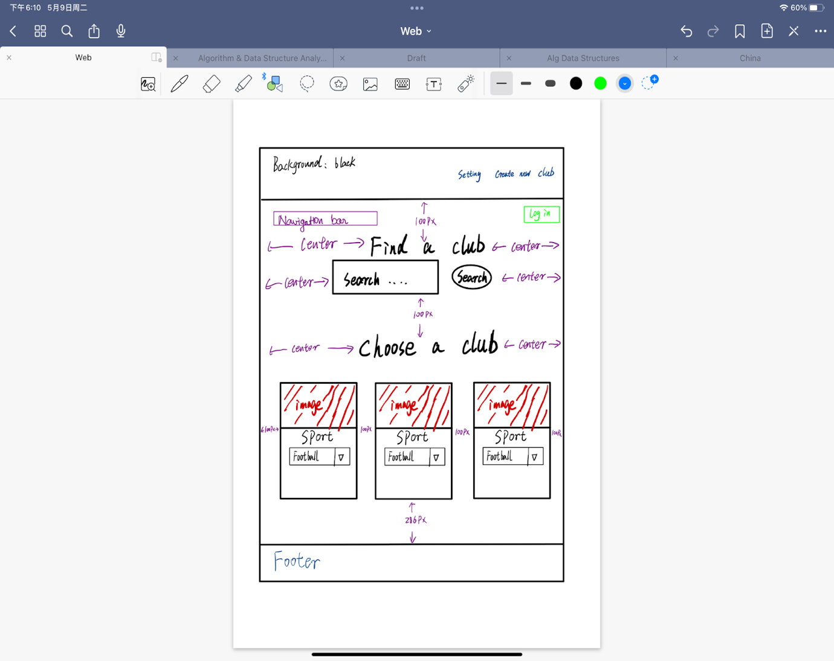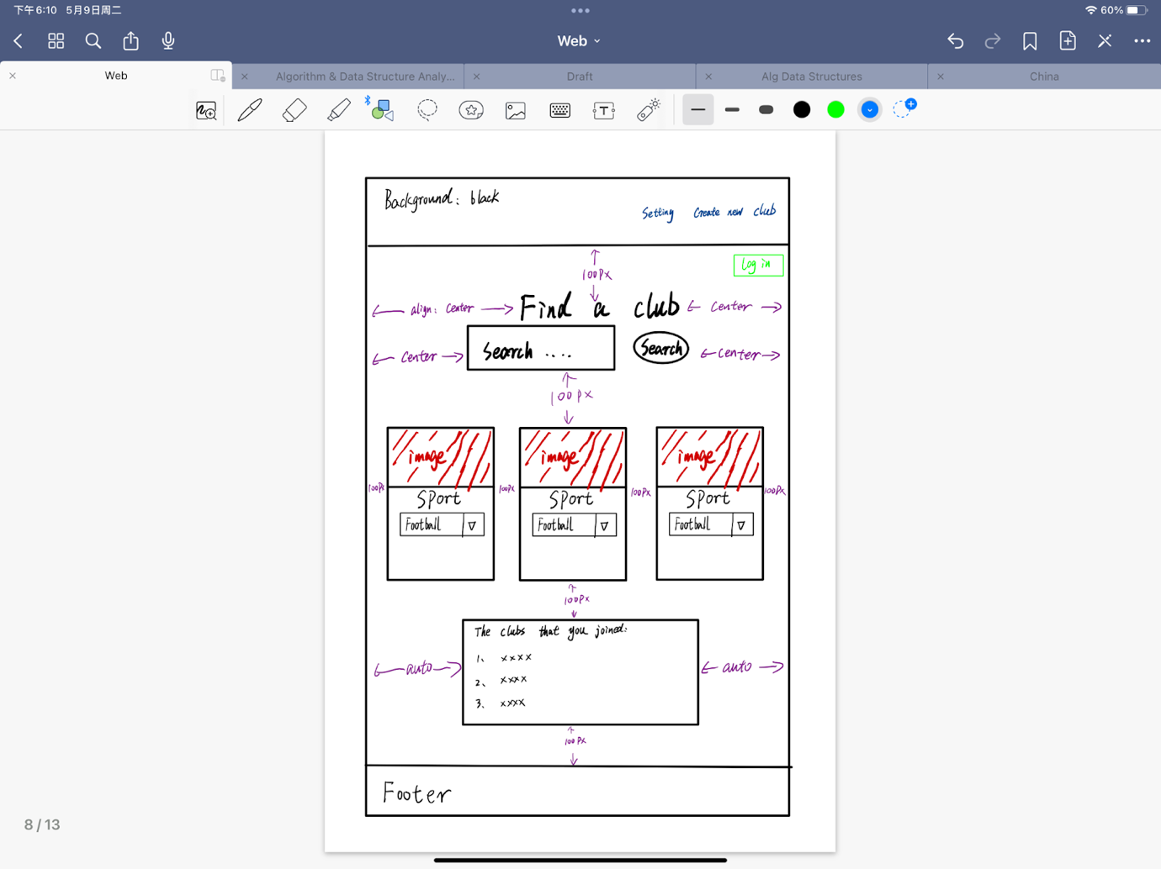

This is the homepage of the website, which serves as the initial interface for non-logged-in users. It features a search box, allowing users to search for clubs, and a drop-down list of pre-categorized club selections for easy browsing . The page also includes a Settings button and a Create New Club button. In the top right corner, there is a green Login button, which redirects users to the login page upon clicking. When the user is logged in, the login button on the main page will change to a logout button. And a list of clubs that the user has joined will appear below the drop-down selection bar. Users can find the clubs they have joined in it.

Components are fixed in size, but the page is stretched. All elements are responsive position, also on mobile.

1. Your Details page

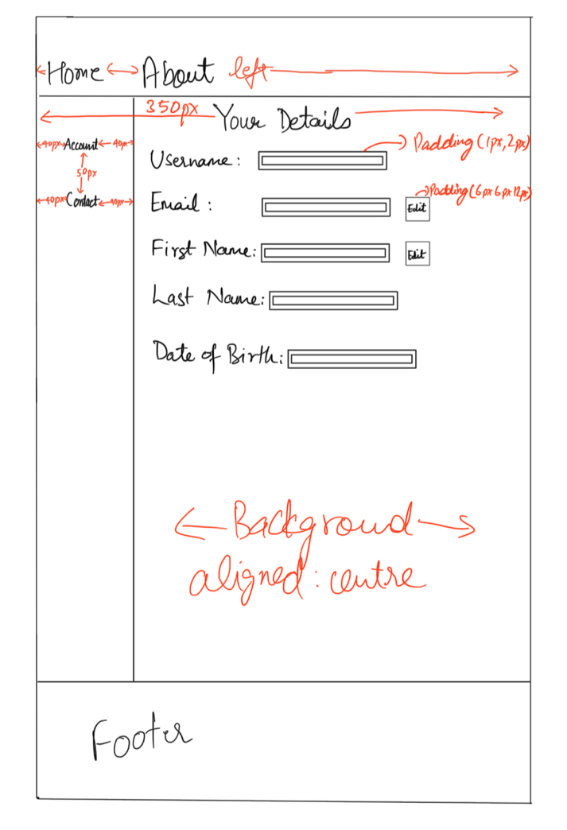

This page has a fixed sidebar wherein the user can see his personal details and edit them accordingly. First name and last name can be edited which will update the database according to these changes. The edit button has been placed specifically next to these editable fields to avoid any confusion.

1. Admin page

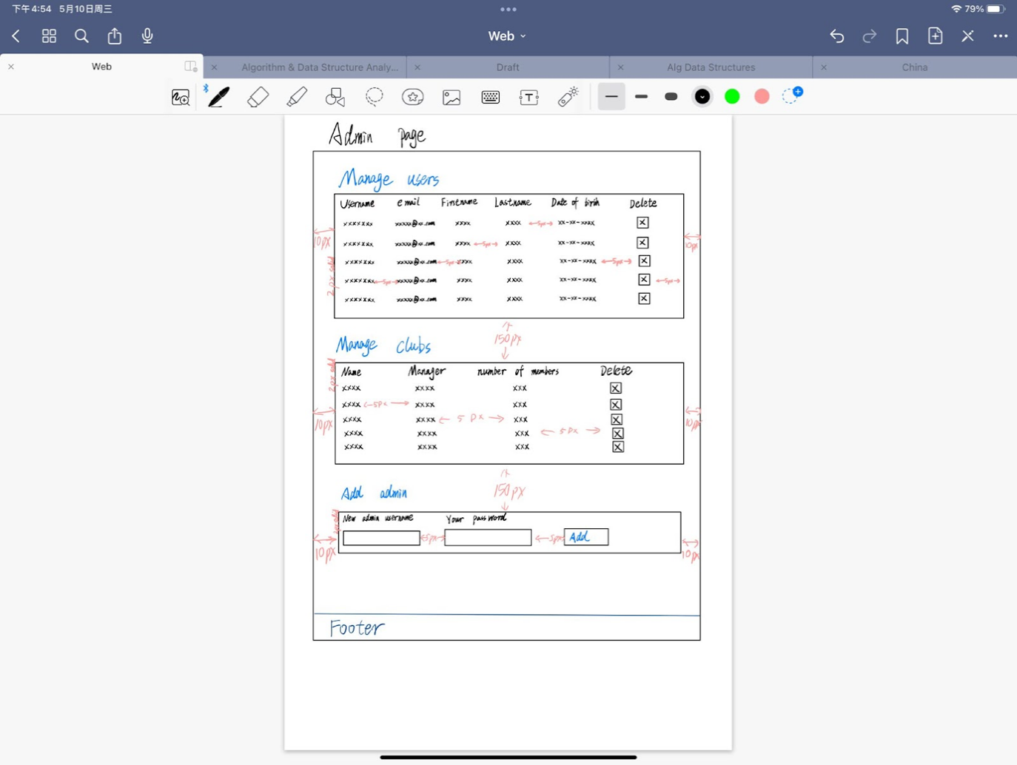

This page contains an option to remove users and club manager. Admin can be added by entering username and password. This will then update the database accordingly. Admin has been granted access to manage both clubs and users and an option to switch admin is provided.

1. Club page (user view)

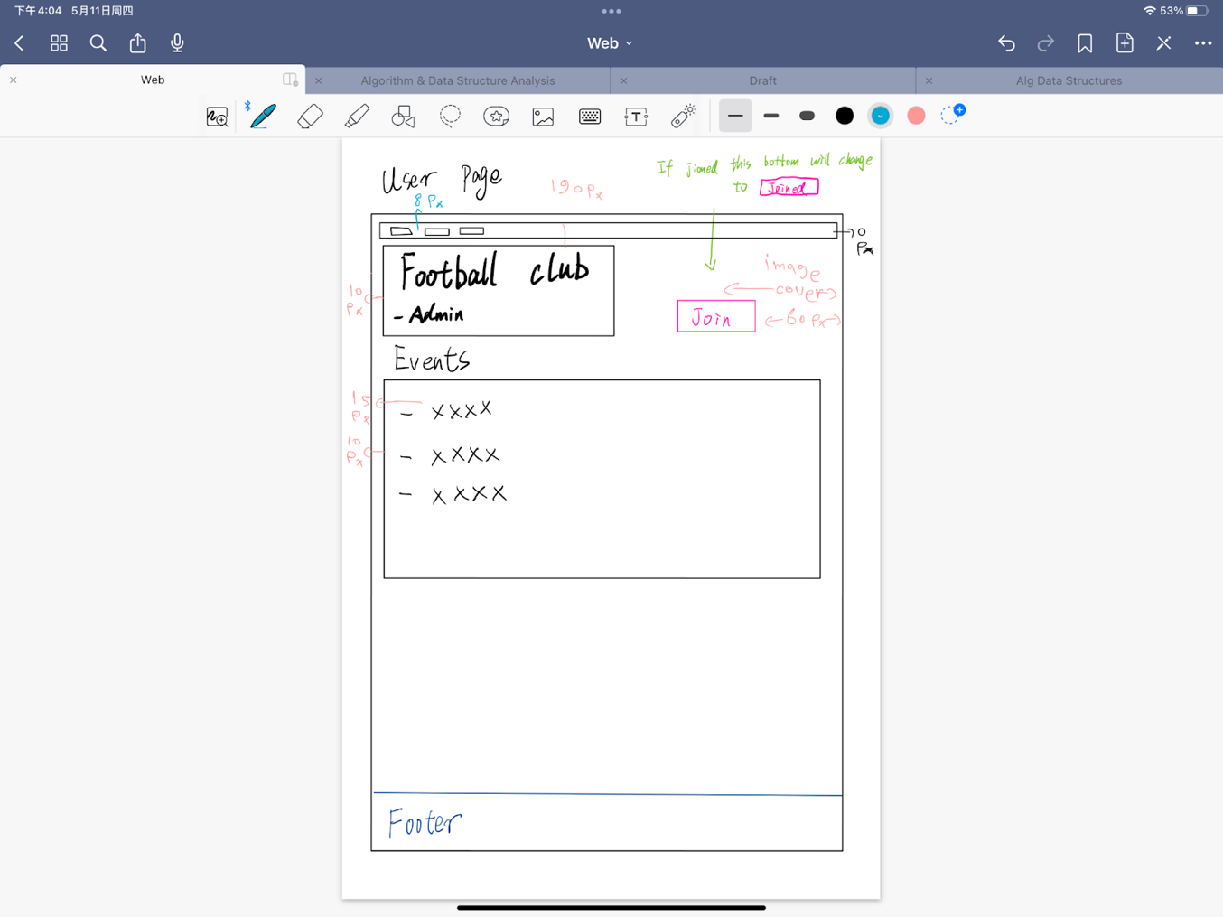

The page consists of a header that contains a nav tag at the top and inside that nav tag there is a div that contains a list of buttons, these buttons placed the top right corner so the user should see them easily ,also it is assumed from the user to know where to find this navigation buttons because most of the websites follow this design. The next part of the header is a div that contains a (background image, a mask on top of the image, club title div and a button) the club title div and the button have been placed next to each other than change the margin to be centred horizontally. Next under the header there is a div for the event that cover all the page. Finally we have the footer that contain plain text but separated to look as block of texts.

1. Club page (admin view)

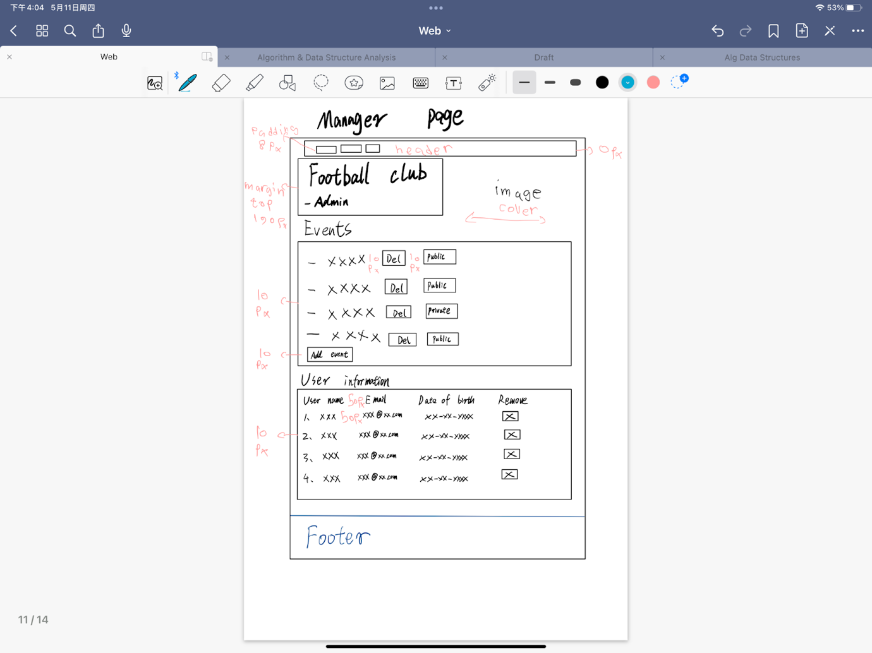

overall the admin page is similar to the user page but there are some differences, the in event box the admin has two buttons   to add and remove events and one box to show event status(public and private), the delete to button and the status box is placed next to the title and location text, there positions are relative to the page size to that when the page is resized they fit properly in the box and the add event button is placed at the end of the box so that whenever an event is added to the list the button will be all way at the bottom. Next, there is the user information box where the information will be displayed as a table, all information will be as plain text, with an auto overflow and except the remove button which will have a relative position.

Review

After completing milestone 1 and getting it reviewed from other groups, our group considered the following implementation will be made in milestone 2, starting with

1. In the login page, we should use the club’s logo on the login page and specify the website’s name.

2. An option to reset password in case the user is unable to access his account should be present in the login page

3. A footer on the login page displaying contact details, email address and links to clubs’ social media pages.

4. In the main page, the various buttons and the images are of reasonable size reducing the kinetic load.

5. A back button should be added across all pages so that the user does not have to go to top-left corner and use browser’s in-built button to go to the previous page. Thus, improving the user navigation.

6. All the pages that are on the website follow similar style and design.

7. Efforts will be made to allow minimal clicks to reach the desire page.

8. Each page will have a navigation bar that will let the user know which page is he on.

9. Most of components of our pages adjust according to the size of window. We will try to implement this same feature for mobile users as well.

10. We have implemented labels and title (on hover) for most of our pages so that if the user has any confusion regarding the functionality of any component of the website, it can be resolved immediately.

11. While creating a new account via the register page, when the register pop-up appears on the page, there’s only one close (X) button from which the user can exit the pop-up. 2 we will try to implement the page such that when the user clicks on the side of the popup, he's able to close the popup.

12. Adding another password input field to make sure admin’s entered password matches will be more function.

Data Plan - in git repository inside the planning folder as XMLHttp_data_plan.xlsx

Data Schema -

